Project Design Phase-II
Technology Stack (Architecture & Stack)

Date | 03-10-2026
Team ID | SWTID-2026-8713
Project Name | Implement Client Script & UI Policy (Incident)
Maximum Marks | 4 Marks
Technical Architecture:
The Deliverable shall include the architectural diagram as below and the information as per the table1 & table

Architecture: Client Scripts and UI Policies on ServiceNow
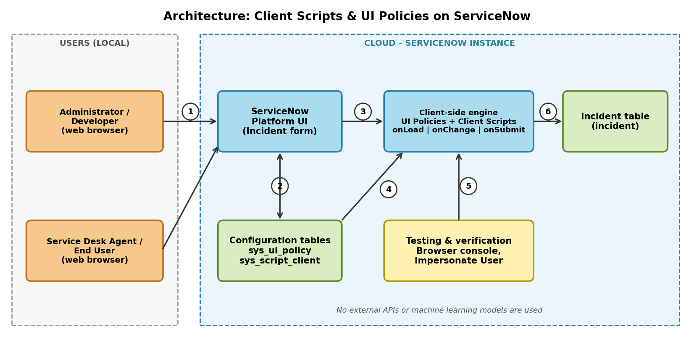
Flow
  - The administrator, developer and agents open the ServiceNow Platform UI in a web browser.
  - The developer creates UI Policies and Client Scripts, which are stored in the configuration tables (sys_ui_policy, sys_script_client).
  - When the Incident form is opened, the form and its rules are delivered to the browser.
  - The client-side engine runs the onLoad Client Scripts and UI Policies to set the initial form state.
  - When a field changes, the onChange scripts and UI Policy conditions update the form without submitting it.
  - On submit, the onSubmit script validates the data and only valid records are saved to the Incident table.
  - Testers check results with the form, the browser console and Impersonate User.
Table-1 : Components & Technologies:
S.No | Component | Description | Technology
1. | User Interface | How the administrator, developer and agent interact  with the application: the Incident form in the  ServiceNow Platform UI in a web browser. | ServiceNow Platform UI (HTML,  CSS, JavaScript in the browser)
2. | Application Logic-1 | UI Policies with conditions and actions that make  fields mandatory, visible or read-only. | ServiceNow UI Policy (client-  side)
3. | Application Logic-2 | Client Scripts that run onLoad, onChange and  onSubmit and control the form using g_form and  g_user. | Client-side JavaScript  (ServiceNow Client Scripts)
4. | Application Logic-3 | UI Policy scripts (Execute if true / Execute if false)  and the order in which policies and scripts run. | ServiceNow UI Policy scripts
5. | Database | Incident table (incident) and the tables that store the  rules (sys_ui_policy, sys_script_client). | ServiceNow platform database
6. | Cloud Database | Database service on the cloud: records and rules  are stored in the ServiceNow instance. | ServiceNow cloud instance
7. | File Storage | No separate file storage is required; the project  works with form rules and records only. | Not applicable
8. | External API-1 | No external API is used in this solution. | Not applicable
9. | External API-2 | No external API is used in this solution. | Not applicable
10. | Machine Learning  Model | No machine learning model is used in this solution. | Not applicable
11. | Infrastructure (Server  / Cloud) | Application deployment on cloud. Local Server  Configuration: not applicable, no local server is  used. Cloud Server Configuration: ServiceNow-  hosted instance. | Cloud (ServiceNow instance)
Table-2: Application Characteristics:
S.No | Characteristics | Description | Technology
1. | Open-Source  Frameworks | No open-source framework is added; the solution  uses native ServiceNow client-side scripting. | ServiceNow client-side  JavaScript
2. | Security  Implementations | Role-based access with server-side ACLs for  enforcement; client rules guide data entry; testing  with Impersonate User and the browser console. | ServiceNow roles, ACLs,  Impersonate User
3. | Scalable Architecture | The same UI Policy and Client Script patterns can  be applied to other forms; the platform separates the  browser, application and database tiers. | ServiceNow multi-tier cloud  platform
4. | Availability | Rules are delivered from the cloud-hosted  ServiceNow instance, so they apply whenever the  instance is available. | ServiceNow cloud instance
5. | Performance | Scripts stay short, run in the browser and avoid  synchronous server calls (for example, GlideRecord)  on the form. | ServiceNow Client Scripts and  UI Policies
References:
https://developer.servicenow.com
https://docs.servicenow.com
https://c4model.com/

